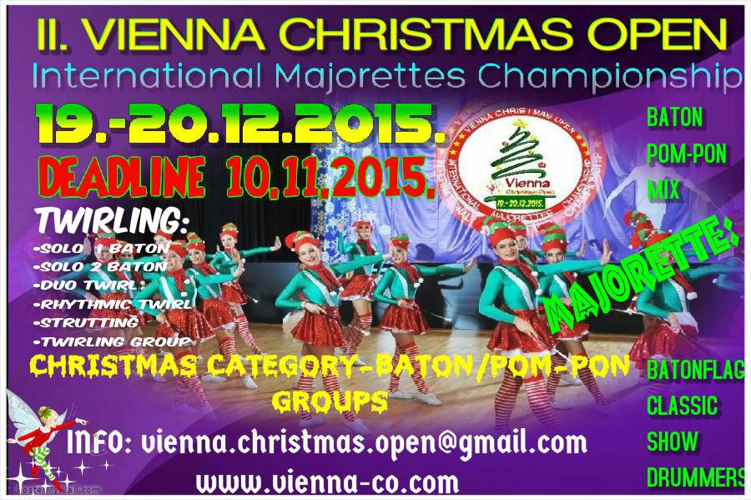

ORGANIZER: | CROATIAN FEDERATION OF MAJORETTES AND POM-PON TEAMS /SMPTH/  AUSTRIAN ASSOCIATION OF MAJORETTES /MVA/
TIME: | 19.-20.12.2015.
VENUE: | sport hall- VIENNA
TYPE OF COMPETITION: | Open international championship in which they can compete all teams regardless of where the association member
REGISTRATION: | 8,00 EUR for each category / each competitor /
APPLICATION  DEADLINE: | 10. 11. 2015.
CONTACT INFO: | E-mail: vienna.christmas.open@gmail.com
WEB: | www.vienna-co.com
REGISTRATION FEE: | SAVEZ MAŽORETKINJA I POM-PON TIMOVA HRVATSKE  Bank account:SAVEZ MAŽORETKINJA I POM-PON TIMOVA HRVATSKE IBAN:HR9224840081101900360 RBA-Raiffeisen bank Austria d.d.  SWIFT: RZBHHR2X

PROGRAM:
SATURDAY, 19.12.2015.
- 08:30-09:30 -registration
- 10:00 - SOLO FORMATIONS BATON-cadets, juniors, seniors
- 14:00 - SOLO FORMATIONS POM-PON-cadets, juniors, seniors
- 17:00 - MIX MINI FORMATIONS-cadets, juniors, seniors
- 18,00- BATON FLAG MINI FORMATIONS-juniors, seniors
- 19:00 -AWARD CEREMONY for SOLO FORMATIONS–diploms, medals, cups
_____________________________________________________________________
SUNDAY, 20.12.2015.
- 10:00 - MIX GROUPS-cadets, juniors, seniors
- 11:00 - POM-PON GROUPS-cadets, juniors, seniors
- 12:30 - BATONFLAG GROUPS–juniors, seniors
- 13:00 -SHOW GROUPS–cadets, juniors, seniors
- 13:30 - CLASSIC MAJORETTES-cadets, juniors, seniors
- 14:15- BATON GROUPS-cadets, juniors, seniors
- 15:30 - CHRISTMAS CATEGORY -BATON-cadets, juniors, seniors
- 16:30 - CHRISTMAS CATEGORY -POM-PON-cadets, juniors, seniors
- 18:00 -AWARD CEREMONY for GROUPS-diploms, medals, cups﻿
___________________________________________________________________________ AWARDS:
- medals, cup, diploms
INFORMATIONS:
E-mail: vienna.christmas.open@gmail.com
www.vienna-co.com

