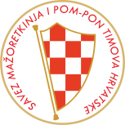
SAVEZ MAŽORETKINJA I POM-PON TIMOVA HRVATSKE
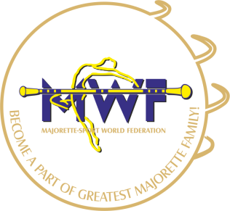
TRENERSKI
SEMINAR
ZAGREB/ 11.-12. 01.2020.
/LICENCIRANI treneri i POLAZNICI trenerske škole-obavezni seminar/
PROGRAM:
SATRUDAY-11.01.2020.
- 09.00 – 12.00
- Thetechniqueofwarm up – preparation, the correct healthy warm up
- Preparations exercises focusing on improvingthe flexibility and stretching the muscles
- 15 min. break
- analysis of gymnastic and acrobatic features
- Explanation of how to begin practicing gymnastic and acrobatic features
- Realization of elements and combination in choreographies, analysis of basic errors

- 12.00-13.00 break

- 13,00– 16.00 -Work with equipment pom-pom
Level /2.level /3.level /4. level
- Combination of work with equipment and gymnastic, acrobatics elements
- Work with colours
- Creation of combinations
- 17.00-19.00 -Elevations
- Groundfloor
- 1.floor
- 2.floor
- throwing in the air, rotating…
SUNDAY/12.01.2020
- 08.30 Summary of the pracical knowledge
- videopresentation
- Evaluation and errors in choreographies pom pom
MJESTO ODRŽAVANJA:
-sportska dvorana OŠ VRBANI
Adresa: Listopdadska ulica 8 / ZAGREB

VODITELJ SEMINARA:
- Elena Martinkova/SK-internacionalni sudac, član MWF Komisije za edukaciju, član MWF- Upravnog odbora, voditelj i trener tima „Bona“ /SK-višestruki europski i svjetski prvaci u kategoriji pom pon
- Treneri i koreografi tima „BONA“ /SK:
- Romana Miklkoisova
- Klára Michaldová

KOTIZACIJA:
-200,00 KN- polaznik trenerske škole
-150,00 KN- licencirani treneri
-60,00 KN- članovi tima/ juniori ili seniori- najviše 2 osobe iz svakoga tima
Uplate na račun SMPTH-a
SAVEZ MAŽORETKINJA I POM-PON TIMOVA HRVATSKE
IBAN:HR922484008110190036
INFO:
E-mail: majorettes.cro@gmail.com
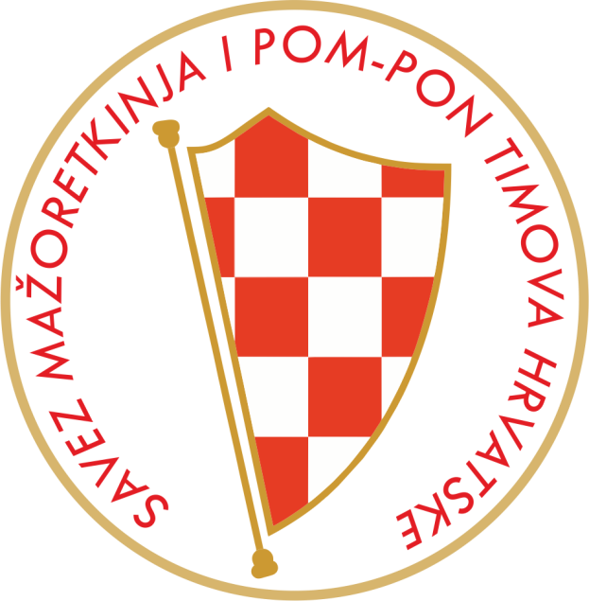
Mob: 095 960 6669
www.smpth-cro.weebly.com

