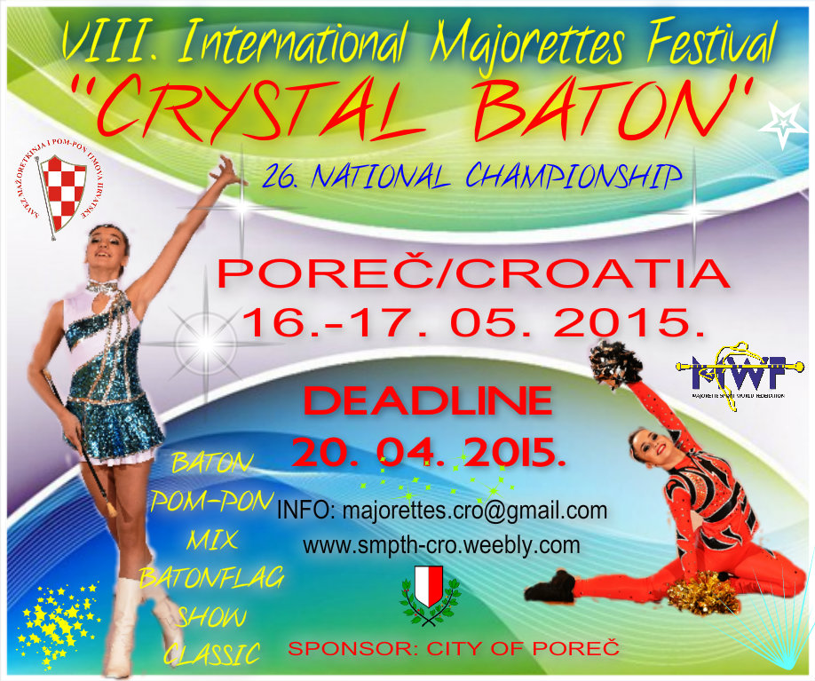

- 09 ,00-11,00-registration-SPORT HALL „VELI JOŽE“-
- 12,00-SOLO FORMATIONS BATON-cadets, juniors, seniors-TRG SLOBODE /stage
- SOLO FORMATIONS POM-PON-cadets, juniors, seniors
- 15,00 –MIX FORMATIONS -cadets, juniors, seniors
- BATON FLAG -juniors, seniors
- 20,00 –SHOW PROGRAM- CEREMONY FOR SOLO FORMATIONS-medals, cups , diploms
____________________________________________________________________________

- 10,00- DEFILE-All participants in the streets of Poreč
- 10,30-OPENING CEREMONY-TRG SLOBODE /stage -In case of rain-sport hall VELI JOŽE
- 11,00-DEFILE BATON- competition-cadets, juniors, seniors
- DEFILE POM-PON- competition-cadets, juniors, seniors
- 14,00-STAGE CHOREOGRAPHY POM-PON-cadets, juniors, seniors
- SHOW CATEGORY -cadets, juniors, seniors
- MIX FORMATIONS-cadets, juniors, seniors
- BATON FLAG FORMATIONS –juniors, seniors
- CLASSIC MAJORETTES-cadets, juniors, seniors
- STAGE CHOREOGRAPHY BATON-cadets, juniors, seniors
- 19,00—SHOW PROGRAM -miss majorette
- FINAL CEREMONY-medals cups, diploms
- ___________________________________________________________________

GROUPS:
-5,00 EUR for every category-each competitor
SOLO FORMATIONS:
-6,00 EUR for every category--solo-/-duo-trio/-mini formations
_____________________________________________________________________________

-medals, cup, diploms
____________________________________________________________________________

E-mail: majorettes.cro@gmail.com
Cell: 00385 91 883 5574/00385 95 960 6669
www.smpth-cro.weebly.com

SAVEZ MAŽORETKINJA I POM-PON TIMOVA HRVATSKE
IBAN:HR9224840081101900360
RBA-Raiffeisen bank Austria d.d.
SWIFT: RZBHHR2X

