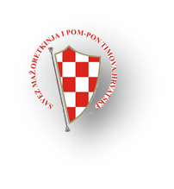
SAVEZ MAŽORETKINJA I POM-PON TIMOVA HRVATSKE
VIII. INTERNATIONAL MAJORETTES CHAMPIONSHIP „CRYSTAL BATON“
26. NATIONAL CHAMPIONSHIP/POREČ,16.-17. 05. 2015.
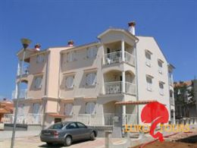
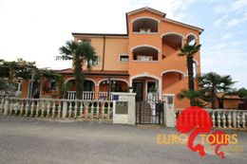
APARTMENTS:-1.APARTMENTS***-„EURO-TOURS“800-1000 person
-12,00 EUR per person-3 and more nights
-14,00 EUR per person-1 -3 night
INFO:-EURO TOURS d.o.o.
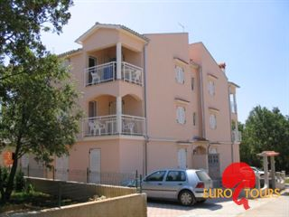
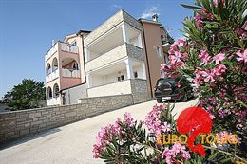
00385/52/433-635
00385/98/340-899
E-mail: euro-tours@euro-tours.net
www.euro-tours.net

2.APARTMENTS POLYNESIA***-1000 person
Poreč –Umag =30 km /http://www.istraturist.com/en/apartments/sol-polynesia/location
- for 1 person-12,00 € /day
INFO:
Elso Maružin
Komercijalist ,
Commercialist t. +385 (0) 52 719107
f. +385 (0) 52 719296
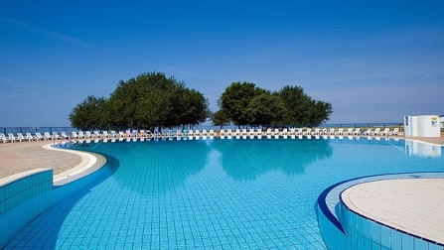
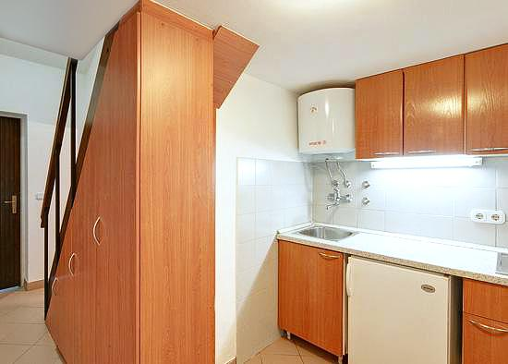
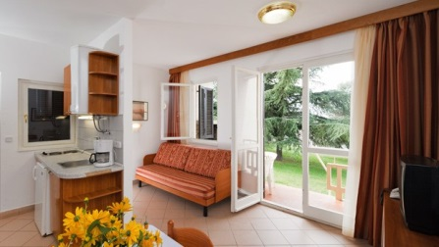
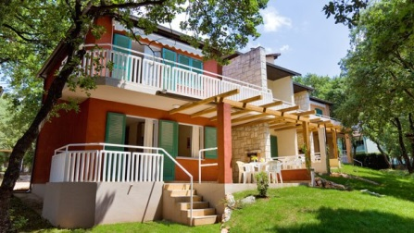
www.istraturist.com
www.istracamping.com

3.BOUTIQUE MATERADA CAMPING BEACH-mobile homes
-1 mobile home-99,00 eur /day- maximum 6 person
CONTACT PERSON:
Matika Suzi
direktor / general manager
 +385 52 219-500
 +385 52 427-104
info@hotelmauro.com
W: www.hotelmauro.com
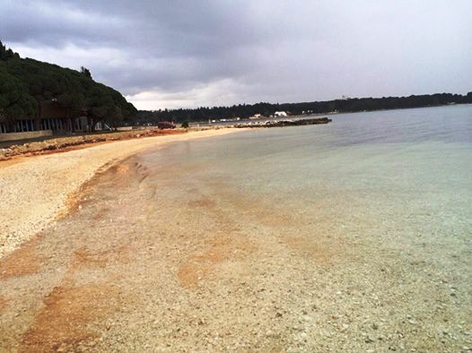
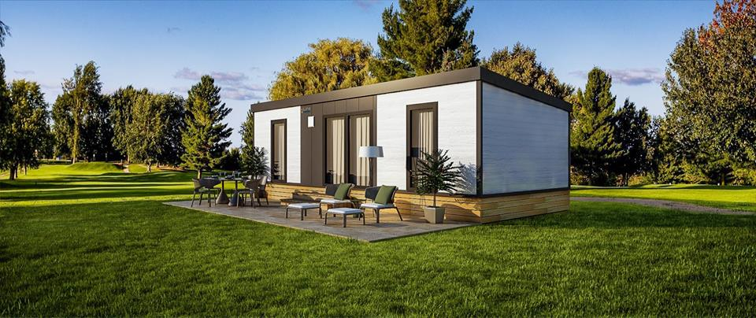
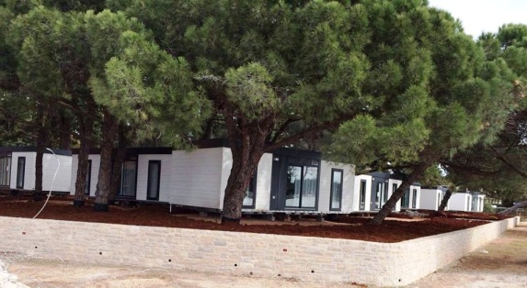

FOOD:
-restaurants near sport hall/Trg slobode
-lunch-5,00 €
-dinner-4,5 €

DATE: | LUNCH: | DINNER: | TOTAL:
16. 05. 2015. | X 5,00 EUR | X 4,5 EUR
17. 05. 2015.
ALL:

