MAJORETTE-SPORT WORLD FEDERATION
MWF meetings
ZAGREB/CRO,28.-30.10.2022.
ACCOMODATION
Deadline/20.01.2022.
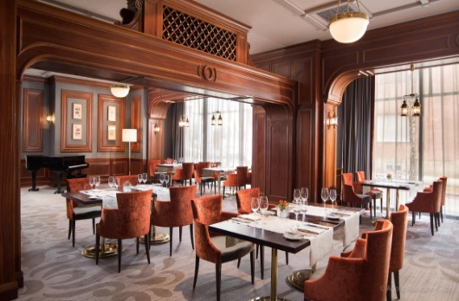
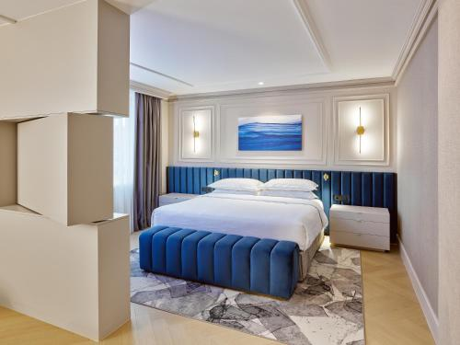
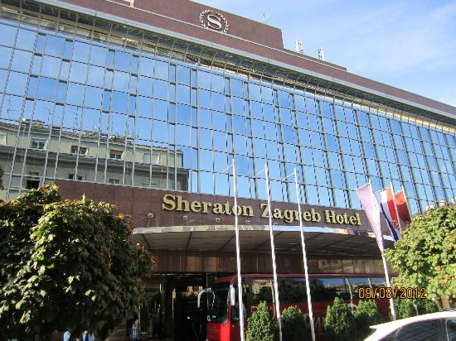
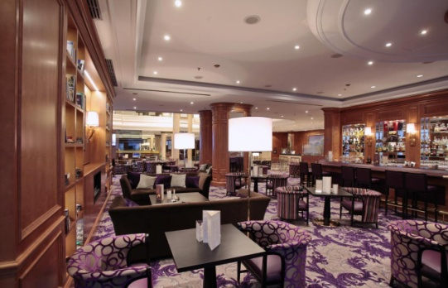
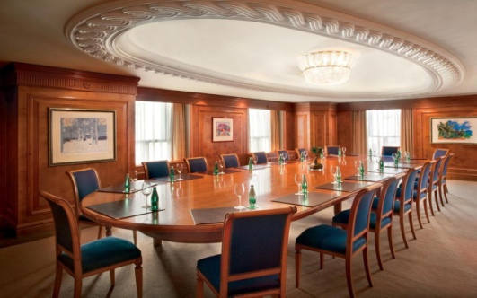
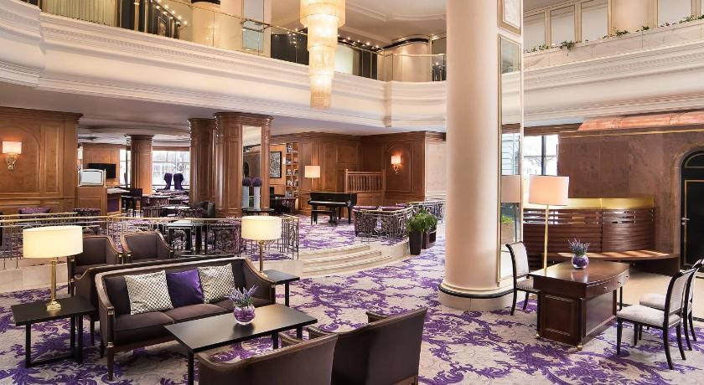
HOTEL SHERATON/ UL. KNEZA BORNE 2 -10 000 ZAGREB-CROATIA

ACCOMODATION-PRICE:
-single room -1 night with breakfast/deluxe room-79.00 Eur
-double room-1 night with breakfast/deluxe room-89.00 Eur
HALF BOARD:
-single room-97.00 Eur
-double room-125.00 Eur
Check inn: 14.00 Check out: 12.00
CONTACT PERSON FOR RESERVATION:
E-mail: Danijela.bozic@hup-zagreb.hr
Mob: 00385 99 379 9914
Organization:
Country:
Name-function:
E-mail/phone:
ADRESS:
Arriving on:
Number of nights:
Room/s:
Date:
Signature:
APPLICATION FOR /ACCOMODATION:

