DEADLINE 15. 08. 2016.
E-mail: majorettes.cro@gmail.com
-payment of 30% to 15. 08. 2016. /ALL -10. 09. 2016.
Adress: SAVEZ MAŽORETKINJA I POM-PON TIMOVA HRVATSKE
Bank account: RBA Raifeissen bank Austria d.d.
IBAN HR922 484 0081 101 900 360
SWIFT: RZBHHR2X

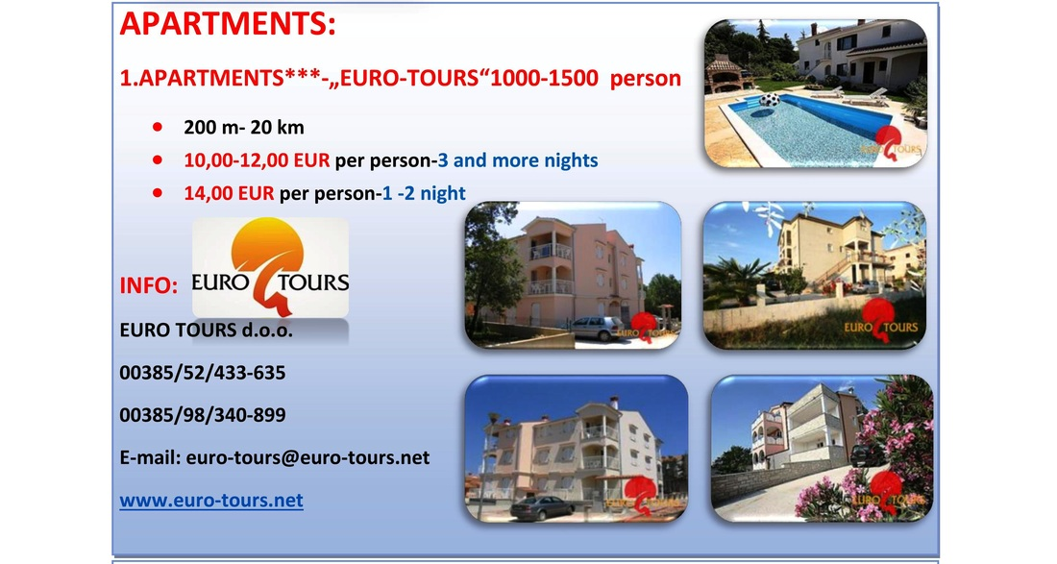

Ggghjjkj

