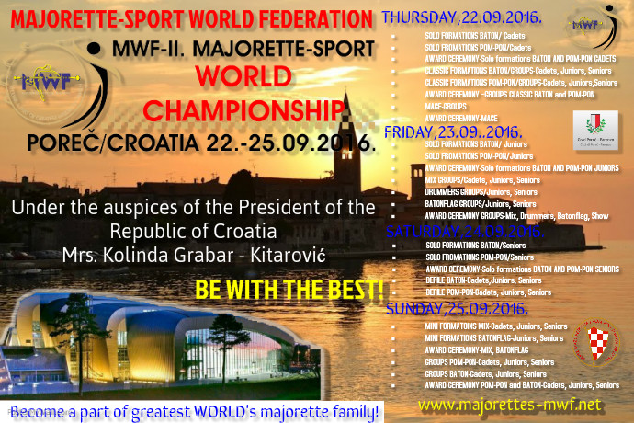

.
THURSDAY,22.09.2016.-Sport hall ŽATIKA
- SOLO FORMATIONS BATON/ Cadets
- SOLO FORMATIONS POM-PON/Cadets
- AWARD CEREMONY-Solo formations BATON AND POM-PON CADETS
- CLASSIC FORMATIONS BATON/GROUPS-Cadets, Juniors, Seniors
- CLASSIC FORMATIONS POM-PON/GROUPS-Cadets, Juniors,Seniors
- AWARD CEREMONY –GROUPS CLASSIC BATON and POM-PON
- MACE-GROUPS
- AWARD CEREMONY-MACE
FRIDAY, 23. 09. 2016. –Sport hall ŽATIKA
• SOLO FORMATIONS BATON/ Juniors
• SOLO FORMATIONS POM-PON/Juniors
• AWARD CEREMONY-Solo formations BATON AND POM-PON JUNIORS
• MIX GROUPS/Cadets, Juniors, Seniors
• DRUMMERS GROUPS/Juniors, Seniors
• BATONFLAG GROUPS/Juniors, Seniors
• AWARD CEREMONY GROUPS-Mix, Drummers, Batonflag, Show
SATURDAY, 24. 09. 2016.-Sport hall ŽATIKA

• SOLO FORMATIONS BATON/Seniors
• SOLO FROMATIONS POM-PON/Seniors
• AWARD CEREMONY-Solo formations BATON AND POM-PON SENIORS
• DEFILE BATON-Cadets,Juniors, Seniors
• DEFILE POM-PON-Cadets, Juniors, Senior
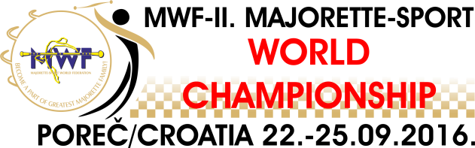
_____________________________________________________________________
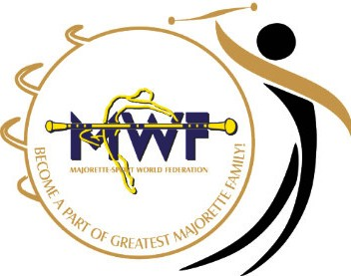
SUNDAY, 25. 09. 2016.-Sport hall ŽATIKA
      - MINI FORMATOINS MIX-Cadets, Juniors, Seniors
      - MINI FORMATIONS BATONFLAG-Juniors, Seniors
      - AWARD CEREMONY-MIX, BATONFLAG
      - GROUPS POM-PON-Cadets, Juniors, Seniors
      - GROUPS BATON-Cadets, Juniors, Seniors
      - AWARD CEREMONY POM-PON and BATON-Cadets, Juniors, Seniors
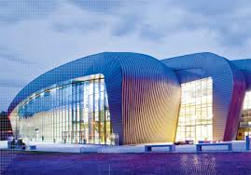
________________________________________________________________________

FREE PARKING NEAR SPORT HALL ŽATIKA:
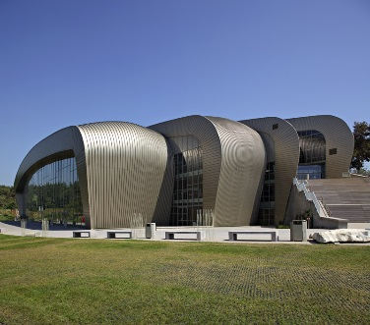
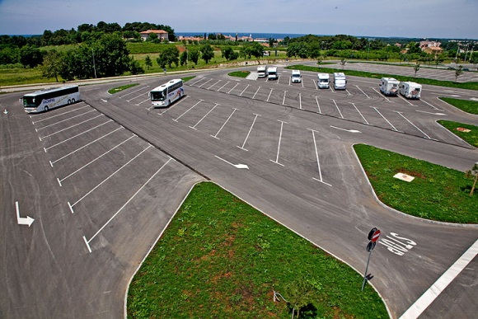

DIRECTIONS :

- In sport hall Žatika for the dressing rooms will be used, exept wardrobes, also a big halls which will be marked as dressing rooms and all because of the big amount of the participates
- On the medal award ceremony teams which have won 6th, 5th or 4th place also gets diploms.
- For 3rd, 2nd and 1st place in categories solo, duo-trio winning teams gets medals and diploms, for mini formations diploms, medals and cups.
- For the opening ceremony at Thursday, 22. 09. 2016. all teams need to be prepared by the sent schedule in 8:30 a.m. so we could start on time with opening ceremony.
- In front of every country there will be a majorette with a sign with name of each country.
- We provided flags for all countries participants. There needs to be a person from the first team of each country which will carry the flag.
- After the opening ceremony flags needs to be lay aside to persons with organizator marks.
- At the opening ceremony first goes person with the name of the country then flag and all teams.
- At the closing ceremony coreographies which have won 1st place in show program: stage choreographies needs to performed.
- After the winners gala concert on the stage comes coaches of all teams for their medals, and each teams gets diplom for participating on MWF-II. Majorette-sport WORLD Championship – Poreč 2016.
- There follow judges and after that presidents of all national associations and president of MWF
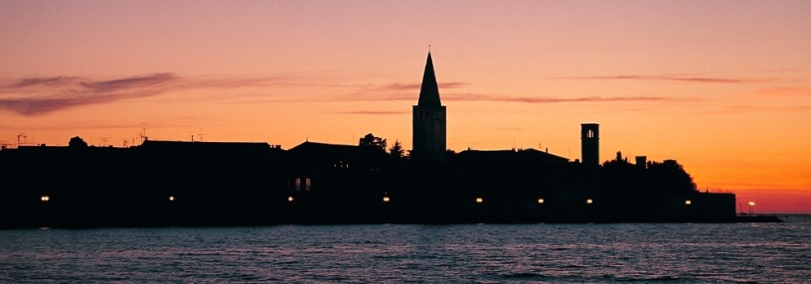
___________________________________________________________________________ WE WISH ALL TEAMS SUCCESSFUL PARTICIPATION ON MWF-II. MAJORETTE-SPORT WORLD CHAMPIONSHIP – POREČ, 22.-35.09.2016.-WELCOME!

