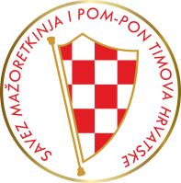
CROATIA GRAND PRIX
International Majorette Sport Championship

BASIC REGISTRATION FORM

E-mail :savez.mazoretkinja.hrvatske@gmail.com

Bank account:
SAVEZ MAŽORETKINJA I POM-PON TIMOVA HRVATSKE IBAN:HR9224840081101900360 RBA-Raiffeisen bank Austria d.d.
SWIFT: RZBHHR2X

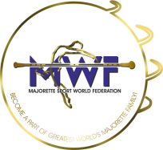
DEADLINE/20.10.2023.

TEAM:
TOWN/PLACE/COUNTRY:
Adress:

E-mail:
Contact person:
Mobile number:

Number of competitors:
KIDS /number/:

CADETS:

JUNIORS:

SENIORS:

Data for invoice:

GROUPS -7,00 EUR- one competitor for every category
BATON  POM-PON  MIX  BATONFLAG  CLASSIC POM PON  DEFILE CLASSIC  DEFILE MAJORETTE SPORT  DEFILE POM PON  DRUMMERS  MACE  SMALL DRILL  TWIRLING ACROBATIC | Kids  CAD  JUN  SEN | Teams name | Num  ber  person
 |  |  | X 8,00eur
SUM person and registration fee per groups

SOLO FORMATIONS:
SOLO-12.00 EUR / DUO-TRIO-10.00 EUR /MINI FORMATION-08.00 EUR
BAT  POM  MIX  B.FLAG  MACE  TWIRLING  DRUMMERS | Kids  CAD  JUN  SEN | solo  duo-trio  mini | Name majorettes and birth year for solo or duo-trio | Num  ber  person
 |  |  |  | X eur
SUM person and registration fee per solo formation
TOTAL:

