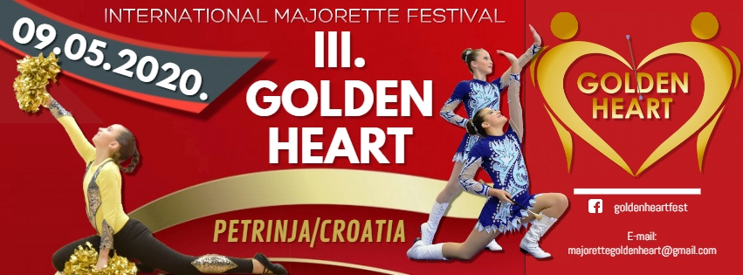

REGISTRATION FORM
DEADLINE 15.04.2020.
_________________________________________________________________
E-mail: majorettegoldenheart@gmail.com
www.golden-heart-fest.weebly.com
SAVEZ MAŽORETKINJE I POM-PON TIMOVA HRVATSKE
Bank account: RBA-Raiffeisen ban Austria d.d. Zagreb
IBAN HR922 484 008 1101 900 360 RBA-Raiffeisen bank Austria d.d.
SWIFT: RZBHHR2X

COUNTRY: TOWN: CLUB/DIVISION:

CONTACT PERSON: MOB: E-MAIL:

SOLO FORMATIONS
BATON KIDS:
 | Quota | Person | Last and first name –solo, duo-trio
1
2
1
2
1
2

BATON CADETS:
 | Quota | Person | Last and first name –solo, duo-trio
1 | solo
2 | solo
1 | Duo-trio
2 | Duo-trio
1 | Mini f.
2 | Mini f.

BATON JUNIORS:
 | Quota | Person | Last and first name –solo, duo-trio
1 | solo
2 | solo
1 | Duo-trio
2 | Duo-trio
1 | Mini f.
2 | Mini f-

BATON SENIORS:
 | Quota | Person | Last and first name –solo, duo-trio
1 | solo
2 | solo
1 | Solo 2 bat.
2 | Solo 2 bat.
1 | Duo-trio
2 | Duo-trio
1 | Mini f.
2 | Mini f.
ACROBATIC BATON SENIORS:

POM-PON KIDS:
 | Quote | Person | Last and first name –solo, duo-trio
1 | solo
2 | solo
1 | Duo-trio
2 | Duo-trio
1 | Mini f.
2 | Mini f.

POM-PON CADETS:
 | Quota | Person | Last and first name –solo, duo-trio
1 | solo
2 | solo
1 | Duo-trio
2 | Duo-trio
1 | Mini f.
2 | Mini f.
OM-PON JUNIORS:
 | Quota | Person | Last and first name –solo, duo-trio
1 | solo
2 | solo
1 | Duo-trio
2 | Duo-trio
1 | Mini f.
POM-PON JUNIORS:
 | Quota | Person | Last and first name –solo, duo-trio
1 | solo
2 | solo
1 | Duo-trio
2 | Duo-trio
1 | Mini f.
2 | Mini f.

POM-PON SENIORS:
 | Quota | Person | Last and first name –solo, duo-trio
1 | solo
2 | solo
1 | Duo-trio
2 | Duo-trio
1 | Mini f.
2 | Mini f.

MINI FORMATION MIX CADETS:
 | Quota | Person
1 | Mini f.
2 | Mini f.

MINI FORMATION MIX JUNIORS:
 | Quota | Person
1 | Mini f.
2 | Mini f.

MINI FORMATION MIX SENIORS:
 | Quota | Person
1 | Mini f.
2 | Mini f.

MINI FORMATION BATONFLAG JUNIORS:
 | Quota | Person
1 | Mini f.
2 | Mini f.

MINI FORMATION BATONFLAG SENIORS:
 | Quota | Person
1 | Mini f.
2 | Mini f.
ACROBATIC SOLO 1 BATON-CADETS:
 | Quota | Person | Last and first name
1
2
3

ACROBATIC SOLO 1 BATON-JUNIORS:
 | Quota | Person | Last and first name
1
2
3

ACROBATIC SOLO 1 BATON-SENIORS:
 | Quote | Person | Last and first name
1
2
3

MACE SOLO-JUNIORS:

 | Quote | Person | Last and first name
1
2
3

MACE DUO- TRIO -JUNIORS:

 | Quote | Person | Last and first name
1
2
3

MACE MINI FORMATIONS-JUNIORS:

 | Quote | Person | Last and first name
1
2
3

MACE SOLO-SENIORS:

 | Quote | Person | Last and first name
1
2
3

MACE DUO-TRIO SENIORS:

 | Quote | Person | Last and first name
1
2
3

MACE MINI FORMATIONS SENIORS:

 | Quote | Person | Last and first name
1
2
3

GROUPS:

FORMATION BATON-KIDS:
 | Quote | Person
1
2

FORMATION BATON-CADETS:
 | Quote | Person
1
2

FORMATION BATON-JUNIORS:
 | Quote | Person
1
2

FORMATION BATON-SENIORS:
 | Quote | Person
1
2

FORMATION BATON GRANDSENIORS:
 | Quote | Person
1
2

FORMATION POM-PON KIDS:
 | Quote | Person
1
2

FORMATION POM-PON-CADETS:
 | Quote | Person
1
2

FORMATION POM-PON JUNIORS:
 | Quote | Person
1
2

FORMATION POM-PON SENIORS:
 | Quote | Person
1
2

FORMATION POM-PON GRANDSENIORS:
 | Quote | Person
1
2

FORMATION MIX-CADETS:
 | Quote | Person
1
2

FORMATION MIX-JUNIORS:
 | Quote | Person
1
2

FORMATION MIX-SENIORS:
 | Quote | Person
1
2

FORMATION BATONFLAG-JUNIORS:
 | Quote | Person
1
2

FORMATION BATONFLAG-SENIORS:
 | Quote | Person
1
2

FORMATION CLASSIC BATON –CADETS:
 | Quote | Person
1
2

FORMATION CLASSIC BATON-JUNIORS:
 | Quote | Person
1
2

FORMATION CLASSIC BATON-SENIORS:
 | Quote | Person
1
2

FORMATION CLASSIC POM-PON–CADETS:
 | Quote | Person
1
2

FORMATION CLASSIC POM-PON –JUNIORS:
 | Quote | Person
1
2

FORMATION CLASSIC POM-PON –SENIORS:
 | Quote | Person
1
2

