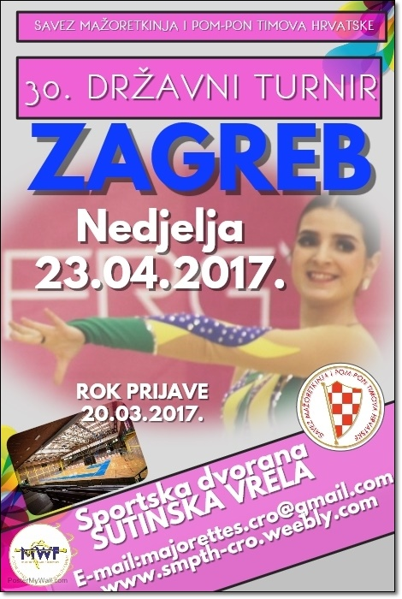
__________________

REGISTRATION FORM

PRIJAVNI LIST

_____________________
DEADLINE
ROK PRIJAVE
20.03.2017.
_____________________________________
ZA SVAKU KATEGORIJU I UZRAST MOGU
SE PRIJAVITI DVIJE FORMACIJE
________________________________________

E-mail: majorettes.cro@gmail.com
www.smpth-cro.weebly.com
COUNTRY:
TOWN:
CLUB/DIVISION:
CONTACT PERSON:
ADRESS:
MOB:
E-MAIL:

SOLO FORMATIONS:

BATON CADETS:

 | Quota | Person | Competitors last and first name – solo / duo-trio
1 | Solo
2 | Solo
1 | duo-trio
2 | duo-trio
1 | Mini
2 | Mini

BATON JUNIORS:

 | Quota | Person | Competitors last and first name – solo / duo-trio
1 | Solo
2 | Solo
1 | duo-trio
2 | duo-trio
1 | Mini
2 | Mini

BATON SENIORS:

 | Quota | Person | Competitors last and first name – solo / duo-trio
1 | Solo
2 | Solo
4 | Solo
1 | Solo-two baton
1 | duo-trio
2 | duo-trio
1 | Mini
2 | Mini

POM-POM CADETS:

 | Quota | person | Competitors last and first name – solo / duo-trio
1 | Solo
2 | Solo
1 | duo-trio
2 | duo-trio
1 | Mini
2 | Mini

POM-POM JUNIORS:

 | Quota | person | Competitors last and first name – solo / duo-trio
1 | Solo
2 | Solo
1 | duo-trio
2 | duo-trio
1 | Mini
2 | Mini

POM-POM SENIORS:

 | quota | person | Competitors last and first name – solo / duo-trio
1 | Solo
2 | Solo
1 | duo-trio
2 | duo-trio
1 | Mini
2 | Mini

MIX CADETS:

 |  | person
1 | Mini f.
2 | Mini f.

MIX JUNIORS:

 |  | person
1 | Mini f.
2 | Mini f.

MIX SENIORS:

 |  | person
1 | Mini f.
2 | Mini f.

BATONFLAG MINI FORMATION-JUNIORS:
 |  | person
1 | Mini f.
2 | Mini f.

BATONFLAG MINI FORMATION-SENIORS:
 |  | person
1 | Mini f.
2 | Mini f.

GROUPS CATEGORY:

BATON GROUPS ( KD=kids CAD = cadets, JUN = juniors, SEN = seniors PR=parents)

Quota | Age category | Group name | Person
1.
2.
1.
2.
1.
2.

POM-POM GROUPS (KD=kids CAD = cadets, JUN = juniors, SEN = seniors PR=parents)

Quota | Age category | Group name | Person
1.
2.
1.
2.
1.
2.

BATONFLAG GROUPS ( JUN = juniors, SEN = seniors )

Quota | Age category | Group name | Person
1.
2.
3.
4.

MIX GROUPS ( CAD = cadets, JUN = juniors, SEN = seniors )

Quota | Age category | Group name | Person
1.
2.
3.
4.
5.
6.

DRUMMERS GROUPS: (JUN=juniors, SEN=seniors)
 | Age category | Group name | Person
1.
2.
3.
4.

CLASSIC GROUPS BATON:
KD=kids CAD=cadets, JUN=juniors, SEN=seniors PR=parents )
 | Age category | Group name | Person
1.
2.
3.
4.
5.
6.

CLASSIC GROUPS POM-PON:
(KD=kids CAD=cadets, JUN=juniors, SEN=seniors PR=parents
 | Age category | Group name | Person
1.
2.
3.
4.
5.
6.

