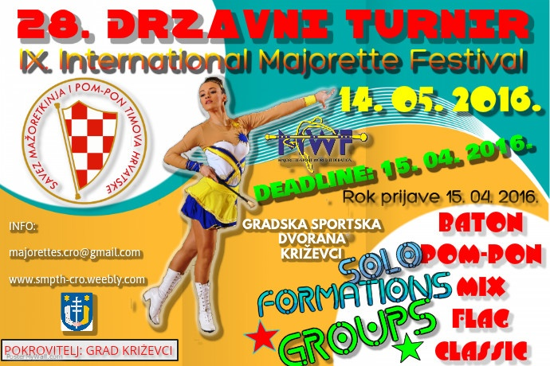

REGISTRATION FORM
DEADLINE 15. 04. 2016.

E-mail: majorettes.cro@gmail.com
www.smpth-cro.weebly.com
COUNTRY:
TOWN:
CLUB/DIVISION:
CONTACT PERSON:
ADRESS:
MOB:
E-MAIL:

SOLO FORMATIONS:

BATON CADETS:

 | Quota | Person | Competitors last and first name – solo / duo-trio
1 | Solo
2 | Solo
1 | duo-trio
2 | duo-trio
1 | Mini
2 | Mini

BATON JUNIORS:

 | Quota | Person | Competitors last and first name – solo / duo-trio
1 | Solo
2 | Solo
1 | duo-trio
2 | duo-trio
1 | Mini
2 | Mini

BATON SENIORS:

 | Quota | Person | Competitors last and first name – solo / duo-trio
1 | Solo
2 | Solo
4 | Solo
1 | Solo-two baton
1 | duo-trio
2 | duo-trio
1 | Mini
2 | Mini

POM-POM CADETS:

 | Quota | person | Competitors last and first name – solo / duo-trio
1 | Solo
2 | Solo
1 | duo-trio
2 | duo-trio
1 | Mini
2 | Mini

POM-POM JUNIORS:

 | Quota | person | Competitors last and first name – solo / duo-trio
1 | Solo
2 | Solo
1 | duo-trio
2 | duo-trio
1 | Mini
2 | Mini

POM-POM SENIORS:

 | quota | person | Competitors last and first name – solo / duo-trio
1 | Solo
2 | Solo
1 | duo-trio
2 | duo-trio
1 | Mini
2 | Mini

MIX CADETS:

 |  | person
1 | Mini f.
2 | Mini f.

MIX JUNIORS:

 |  | person
1 | Mini f.
2 | Mini f.

MIX SENIORS:

 |  | person
1 | Mini f.
2 | Mini f.

BATONFLAG MINI FORMATION-JUNIORS:
 |  | person
1 | Mini f.
2 | Mini f.

BATONFLAG MINI FORMATION-SENIORS:
 |  | person
1 | Mini f.
2 | Mini f.

GROUPS CATEGORY:

BATON GROUPS ( CAD = cadets, JUN = juniors, SEN = seniors )

Quota | Age category | Group name | Person
1.
2.
1.
2.
1.
2.

POM-POM GROUPS ( CAD = cadets, JUN = juniors, SEN = seniors )

Quota | Age category | Group name | Person
1.
2.
1.
2.
1.
2.

BATONFLAG GROUPS ( JUN = juniors, SEN = seniors )

Quota | Age category | Group name | Person
1.
2.
3.
4.

MIX GROUPS ( CAD = cadets, JUN = juniors, SEN = seniors )

Quota | Age category | Group name | Person
1.
2.
3.
4.
5.
6.

DRUMMERS GROUPS: (JUN=juniors, SEN=seniors)
 | Age category | Group name | Person
1.
2.
3.
4.

CLASSIC GROUPS BATON: (CAD=cadets, JUN=juniors, SEN=seniors)
 | Age category | Group name | Person
1.
2.
3.
4.
5.
6.
CLASSICGROUPS POM-PON: (CAD=cadets, JUN=juniors, SEN=seniors)
 | Age category | Group name | Person
1.
2.
3.
4.
5.
6.

